StarShield Affiliate Portal
Specification & Architecture
Two roles only: Affiliate (User) & Admin
Date: 2025-10-25

1. Goals & Roles
Build a reliable, mobile-friendly Affiliate portal and a desktop-first Admin portal with accurate attribution, flexible commission rules, clear analytics, and streamlined payouts.
Roles: Affiliate (User), Admin.

2. Features

2.1 Affiliate Portal (mobile-first)
- Onboarding (KYC/tax, payout method, e‑signature T&Cs)
- Dashboard (clicks, conversions, revenue, commission, top products)
- Product catalog with details, creatives, shareable links, QR codes, UTM templates
- Link & Coupon manager (deep links, short links)
- Reports (time-series, order-level), CSV/Excel export
- Payouts (balances, pending/approved/paid, receipts)
- Notifications (sales, payouts, policy changes)
- Help Center (FAQ, contact form)

2.2 Admin Portal (desktop)
- Overview KPIs, anomalies, leaderboards
- Affiliate management (approve/suspend, KYC state)
- Commission rules (percent/flat, scopes, time windows) with simulation
- Orders & Refunds ingestion (idempotent), reversals
- Payout batches → submit to provider → receipts
- Reports (scheduled + on-demand)
- Attribution policy (last‑click vs coupon) and windows
- Fraud checks (bot/velocity/self‑purchase), Audit logs
- Settings (integrations, consent text, email templates)

3. Architecture
Modular monolith with clear boundaries: NestJS services, PostgreSQL OLTP, Redis cache, queue for async jobs, ClickHouse for analytics, S3 for assets, behind CDN and API Gateway.
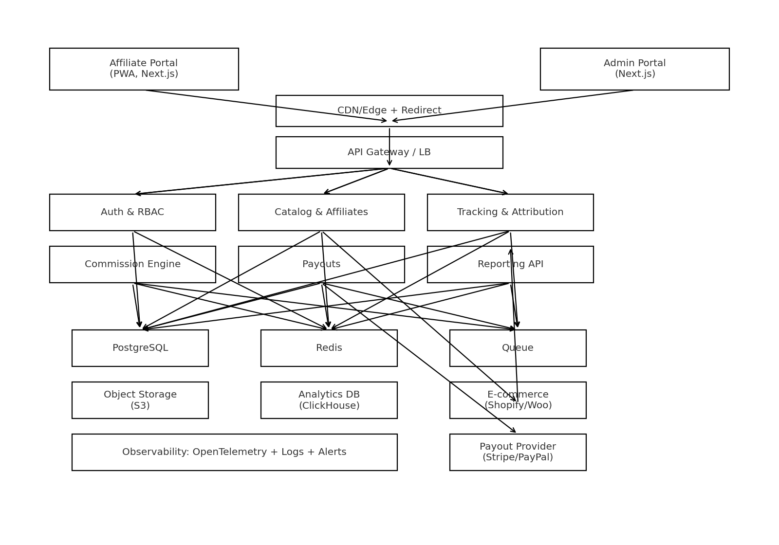
Figure 1: High-level architecture (Affiliate + Admin)

4. Core Flow: Click → Order → Commission
Redirect endpoint sets first‑party cookie and logs click. Storefront sends paid-order webhook. System attributes to coupon/last click based on policy, writes commission ledger (pending → approved → paid).
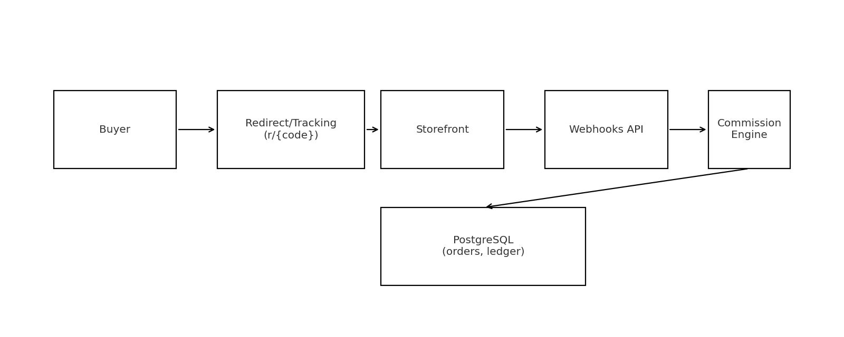
Figure 2: Click → Order → Commission sequence

5. Tech Stack
- Frontend: Next.js (React, TS), Tailwind CSS + shadcn/ui, TanStack Query, Zod, React Hook Form, Recharts; PWA for Affiliate.
- Backend: NestJS (TS), REST + OpenAPI, Prisma ORM → PostgreSQL, Redis, SQS/RabbitMQ, ClickHouse, S3.
- Integrations: Shopify; Stripe Connect/ SES/SendGrid + Twilio.
- DevOps: AWS (ALB, ECS/EKS, RDS, ElastiCache, S3, CloudFront, Secrets Manager, SQS), GitHub Actions CI/CD, OpenTelemetry.

6. Data Model (ERD)
Normalized schema to support attribution, commission ledger, and payouts. Key tables: users, affiliate_profiles, products, categories, affiliate_links, coupons, clicks, orders, order_items, attribution, commission_rules, commission_ledger, payout_batches, payout_lines, refund_events, audit_log.
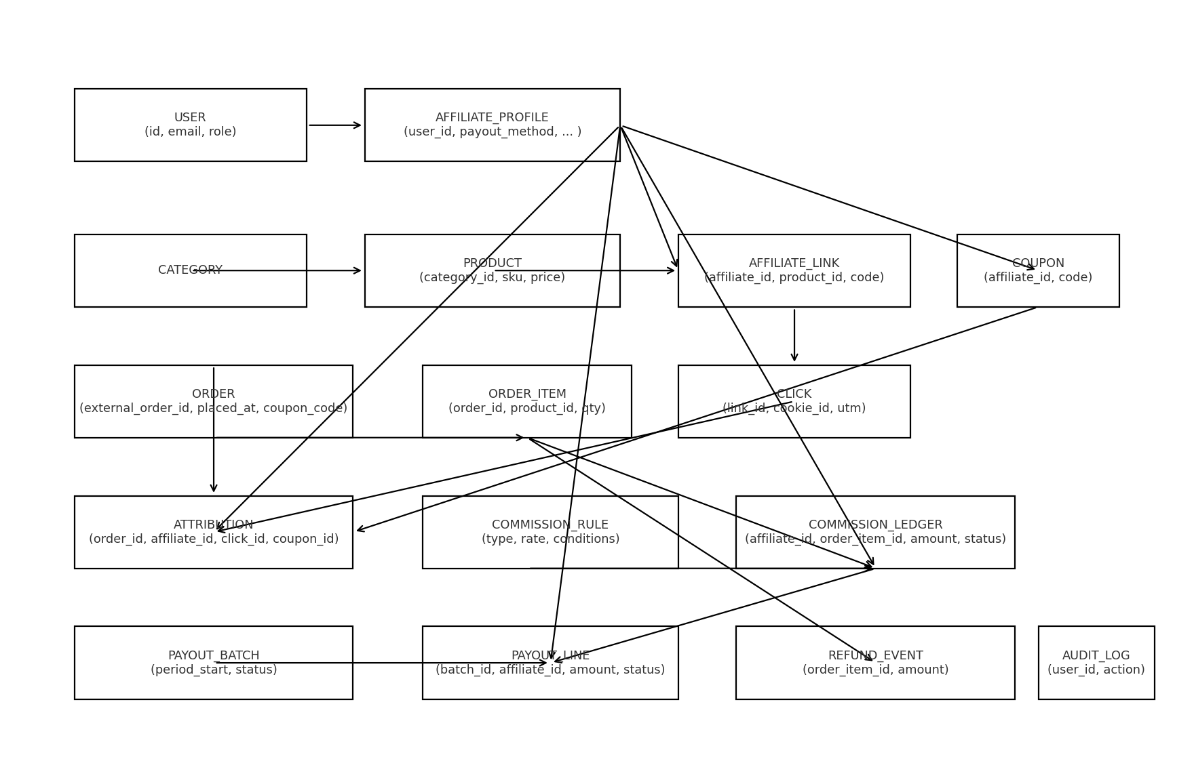
Figure 3: ERD (overview)

7. Attribution & Commission Policies
Configurable policies: coupon‑first or last‑click (30‑day default window). Bot filtering, self‑purchase blocking, refunds create reversal entries. Lifecycle: pending → approved → paid; FX conversion at EOD for multi‑currency.

8. API Overview
Key endpoints include: /auth/*, /me/*, /products, /me/links, /me/coupons, /r/{code}, /webhooks/orders, /webhooks/refunds, and admin endpoints for affiliates, commission rules, payouts, reports. See Appendix B for OpenAPI excerpt.

9. Security & Privacy
- HTTPS/HSTS, CSP, rate limiting, WAF; JWT + refresh (optional 2FA).
- PII encryption at rest; audit logging of all admin mutations.
- Consent banner + logs; configurable cookie and attribution windows.

10. Roadmap
- Phase 1 (MVP): tracking, catalog sync, orders+last‑click attribution, basic rules, dashboards, CSV export.
- Phase 2: payouts, refunds/reversals, coupon mapping, fraud checks, audit logs, scheduled reports.
- Phase 3: multi‑touch attribution, rule simulation, advanced analytics, PWA offline.

